**Superstore Sales Performance - Capstone Project**

**Tableau Project Requirement**

* The workbook should have a single dashboard.
* Each worksheet/view/chart should meet the business requirement.
* All worksheets should be hidden.
* Workbook should be published to Tableau Public if possible.

**Business Requirement**  
Connect to the Sample Superstore dataset and build a Dashboard that will show the Sales Performance.  
  
**View 1: Total Sales**

* The sheet should only display the Total Sales in thousands, along with the header “Total Sales”.
* The Total Sales displayed should have the color code “#76b7b2”. Use the Color Palette.
* Disable Tooltip for this view.
* Use the background color of your choice.
* Name the sheet as “Total Sales”.

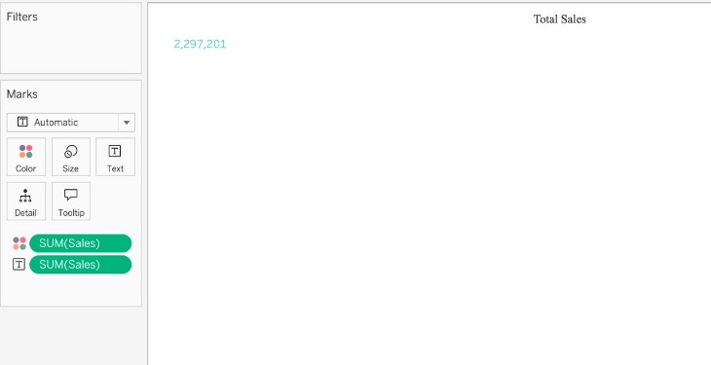

**View 2: Total Profit**

* Requirements are the same as for the view “Total Sales”.

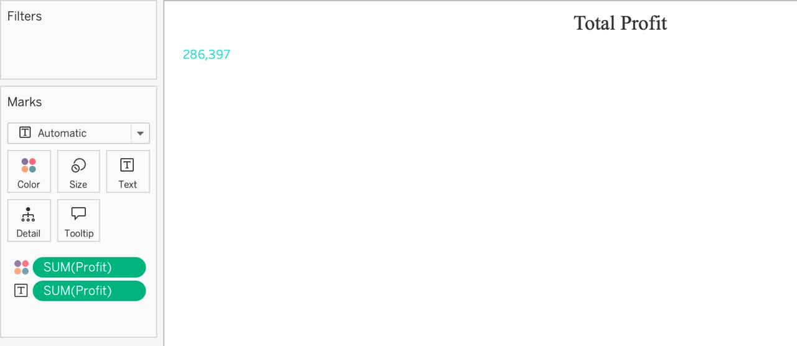

**View 3: Total Volume**

* Requirements are the same as for the view “Total Sales”, except it’s not a currency value.

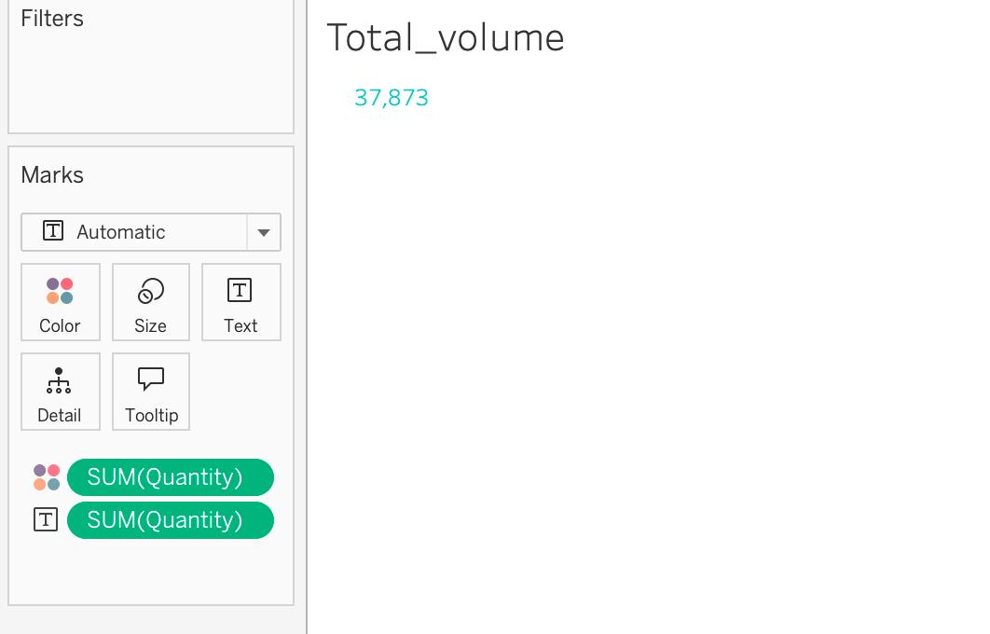

**View 4: Sales Per Customer**

* Requirements are the same as for the view “Total Sales“.

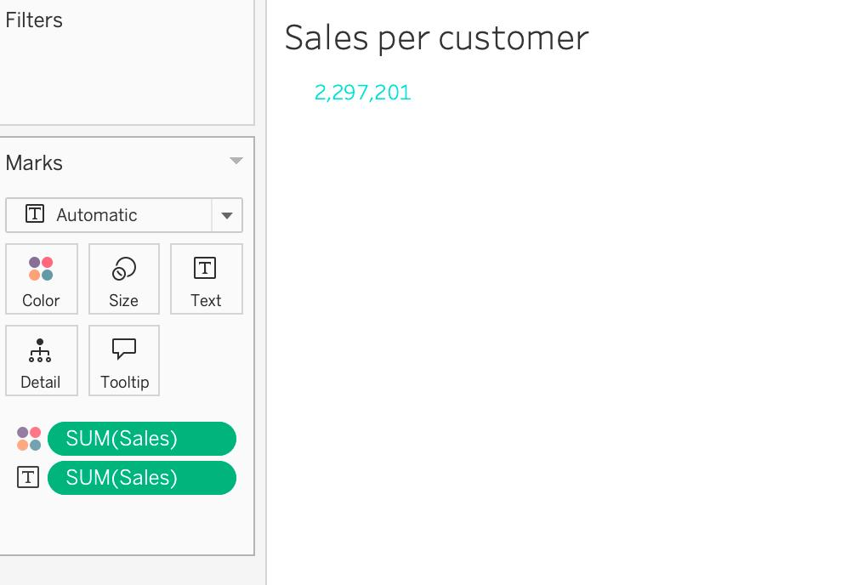

**View 5: Pie Chart**

* Pie Chart should display the percent of Total Sales by Region.
* Use the Summer Color Palette. Pie Chart should have black borders.
* Tooltip should be formatted as seen below showing Region Name, Percent of Total Sales, and the Total Sales value formatted in currency and displayed in thousands (K).

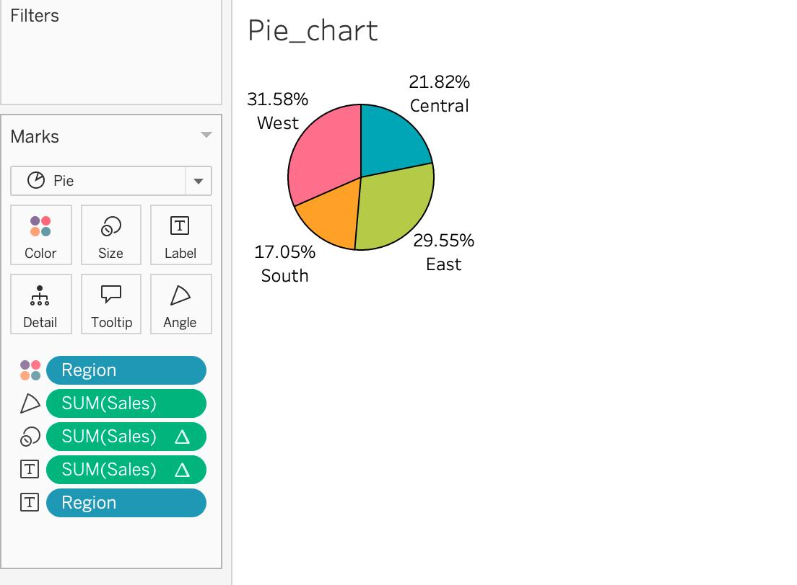

**View 6: Bar Chart**

* Horizontal Bar Chart should display the top N states by Sales.
* Using a Parameter, the user should be able to change the value of N.
* Use the color of your choice for the bars along with the labels displayed in $.
* Data should always be sorted in descending order.

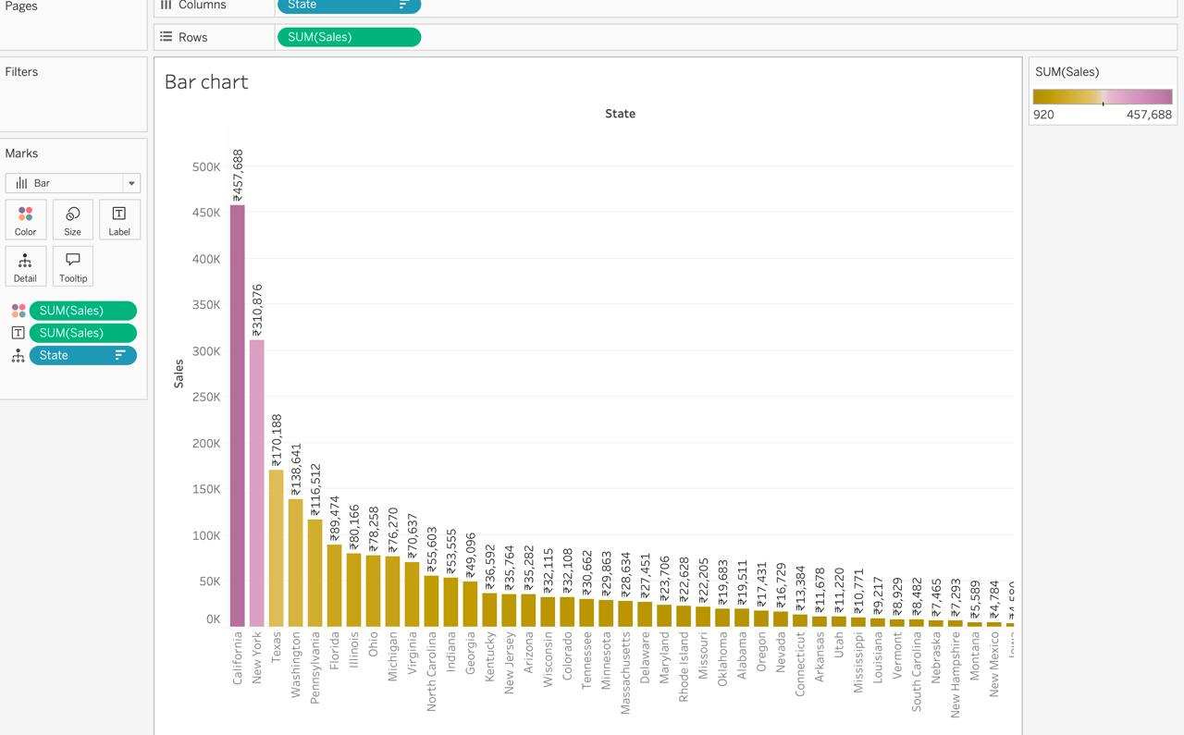

**View 7: Bubble Chart**

* Bubble chart should display Sales by sub-category.
* Bubbles should be colored by category.
* Use the color of your choice for the bubble.
* Tooltip should display only sub-category along with the sales value in $ in thousands (K).

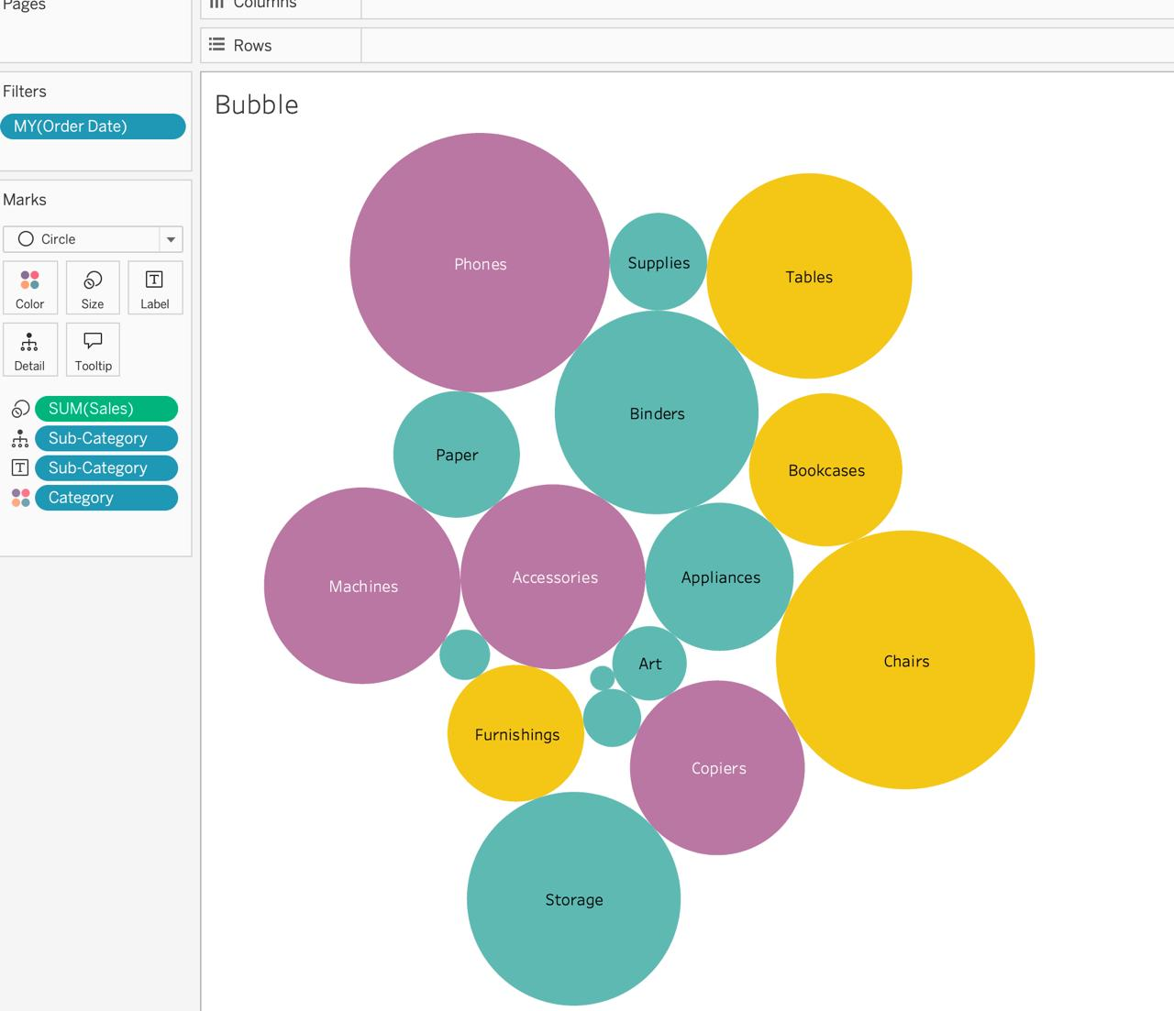

**View 8: Line Chart**

* A continuous line chart should display the Sales trend by Month-Year.
* X-axis should display month and year in the format MMM YY. For example, Mar 22 [Year 2022].
* Hide the axis titles only.
* Tooltip should display only Month-Year, along with the sales value in $ in Thousands (K).
* Use Order Date as a Date Range filter.
* Name the sheet as shown below and color the tab.

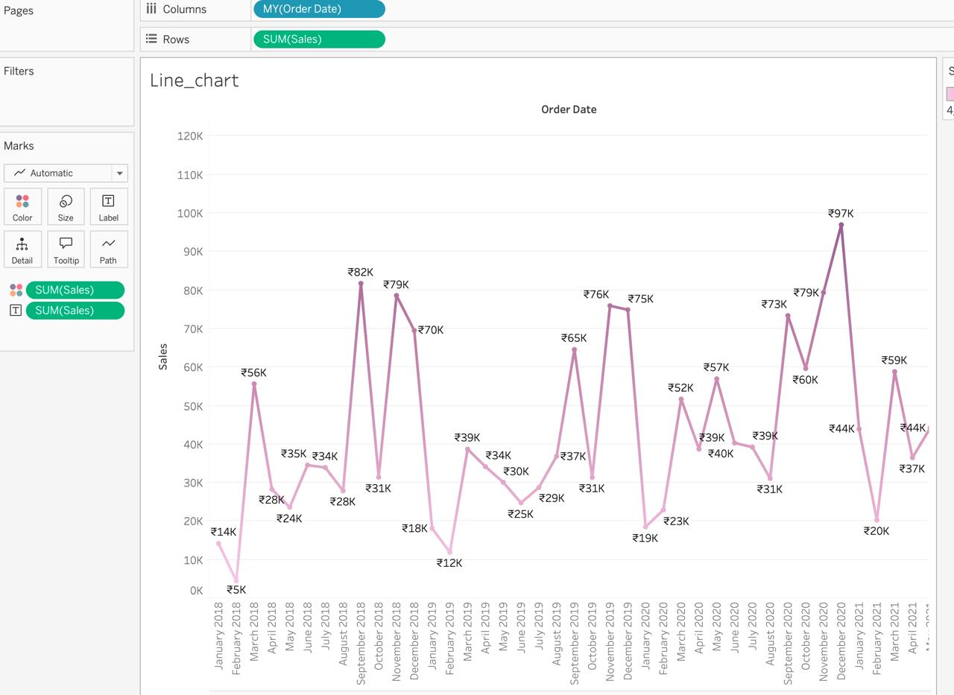

**Dashboard Requirements**

* Dashboard Name: Sales Dashboard
* Dashboard Title: Superstore Sales Performance
* Dashboard description: Sales overview of the superstore data
* Dashboard size: Should be set to FIXED size. Width – 1055, Height – 850
* Dashboard Filters:
* Filters to be present in dashboard:

1. Order Date – Show as Range of date. This filter should be applied to all worksheets.
2. Segment – Show as multiple values (drop-down) with the Apply button and showing only relevant values. This filter should be applied to all worksheets.
3. Ship Mode – Show multiple values (drop-down) with the Apply button and show only relevant values. This filter should be applied to all worksheets.
4. State – Show multiple values (drop-down) with the Apply button and show only relevant values. This filter should be applied to all worksheets except the bar chart.

* Filter Formatting:

1. Format the filter background to any color.
2. Add borders if necessary.
3. Place all these filters in a horizontal container and distribute them evenly.

